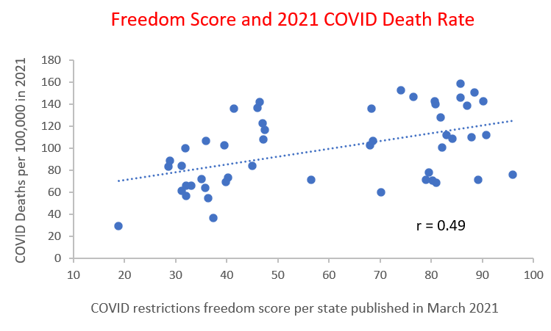
Chart 1: There is a significant correlation between lack of COVID restrictions and COVID death rates in 2021.

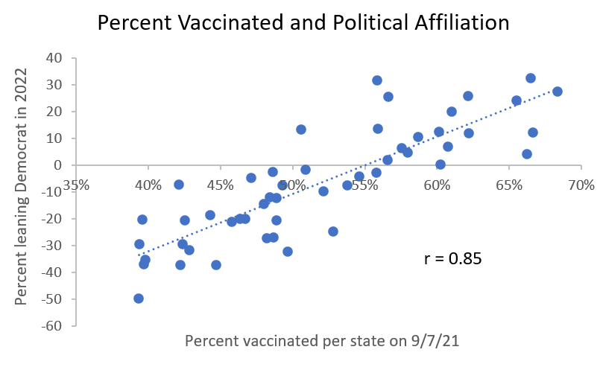
Chart 3: There is a very significant correlation between percent vaccinated in 2021 and political affiliation.

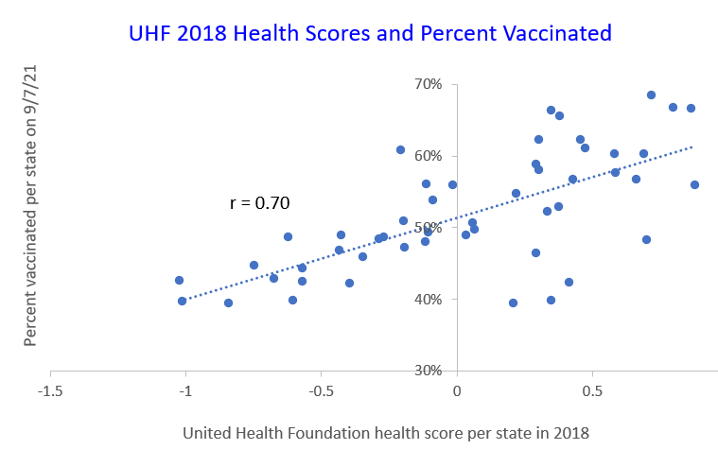
There is a very significant correlation between health scores in 2018 and percent vaccinated in 2021. This indicates health user bias in Chart 2.
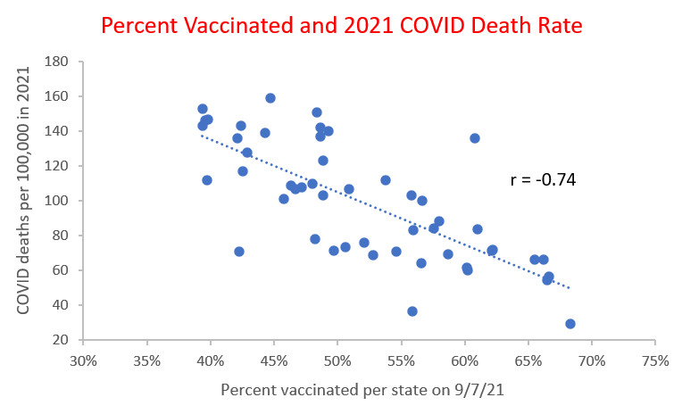
Chart 2: There is a very significant correlation between percent vaccinated and COVID death rates in 2021.

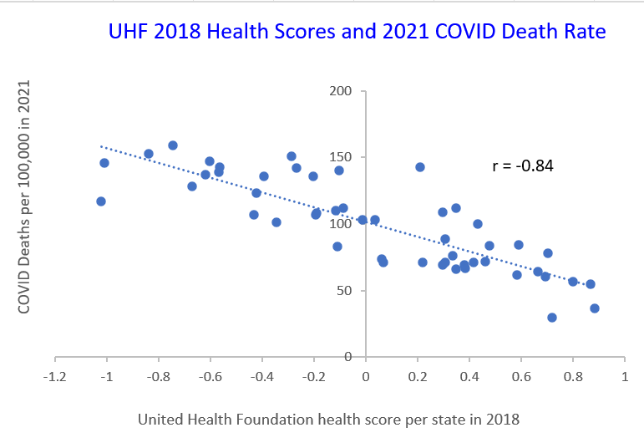
Chart 4: There is a very significant correlation between health scores in 2018 and COVID death rate in 2021. Comorbidities played a major role in “COVID” mortality.

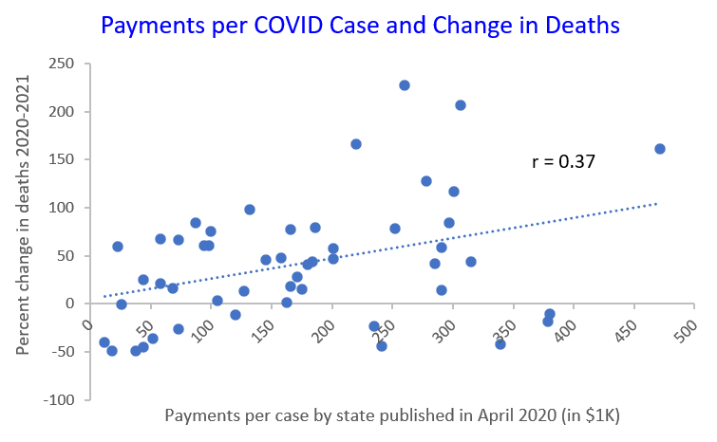
There is a marginally significant correlation between CARES payments per COVID patient in 2020 and percent change in COVID deaths from 2020 to 2021. Did larger payments compel these states to inflate their COVID numbers in 2021?

Sources:
Freedom score | https://wallethub.com/edu/states-coronavirus-restrictions/73818
$/COVID case | https://www.beckershospitalreview.com/finance/state-by-state-breakdown-of-federal-aid-per-covid-19-case.html
COVID deaths | https://www.cdc.gov/nchs/pressroom/sosmap/covid19_mortality_final/COVID19.htm
poverty | https://www.forbes.com/sites/andrewdepietro/2021/11/04/us-poverty-rate-by-state-in-2021/?sh=8c920b1b38fd
urbanization | https://www.visualcapitalist.com/sp/mapping-us-urbanization-by-state/
life expectancy | https://www.cdc.gov/nchs/pressroom/sosmap/life_expectancy/life_expectancy.htm
health | https://www.forbes.com/advisor/health-insurance/best-worst-states-for-healthcare/
health | https://nccd.cdc.gov/BRFSSPrevalence/rdPage.aspx?rdReport=DPH_BRFSS.ExploreByTopic&irbLocationType=StatesAndMMSA&islClass=CLASS08&islTopic=TOPIC24&islYear=2022&rdRnd=30901
health UHF | https://assets.americashealthrankings.org/app/uploads/2018ahrannual_020419.pdf
vax 2021 | https://ourworldindata.org/us-states-vaccinations
political | https://fivethirtyeight.com/features/how-red-or-blue-is-your-state-your-congressional-district/
>65 | https://www.census.gov/library/visualizations/interactive/population-65-and-older-2021.html

